**Software Engineering Tools Lab**

**Assignment No-8**

**Module 5- Software testing using tools**

**PRN: 2020BTECS00069**

**Name: Yashraj Patil**

**Q 1. What are the prerequisites for installing the TestLink tool.**

Operating System: Windows, Linux, or Mac OS X

Web Server: Apache or IIS

Database: MySQL, PostgreSQL, or Microsoft SQL Server

PHP: Version 5.6.x or higher

PHP Extensions: mbstring, gd, xml, mysqlnd, mysqli or pdo_mysql, zip

Browser: Any modern web browser such as Chrome, Firefox, or Safari

**Q 2. Install TestLink tool on your machine (Provide screen shots for successful installation and login)**

1. Download the latest stable version of TestLink from the official website (<https://testlink.org/>).
2. Extract the downloaded ZIP file to a directory on your machine.
3. Copy the extracted TestLink folder to your web server's document root directory.
4. Create a new database for TestLink and grant a user with necessary privileges to access the database.
5. Rename the configuration file config.inc.php.sample to config.inc.php and modify the necessary configuration settings such as database connection details.
6. Open a web browser and navigate to the TestLink installation URL (e.g., <http://localhost/testlink/install/index.php>).
7. Follow the on-screen instructions to complete the installation process, providing the necessary details such as database connection details and administrator account information.
8. Once the installation is complete, login to TestLink using the administrator account that you created during the installation process.

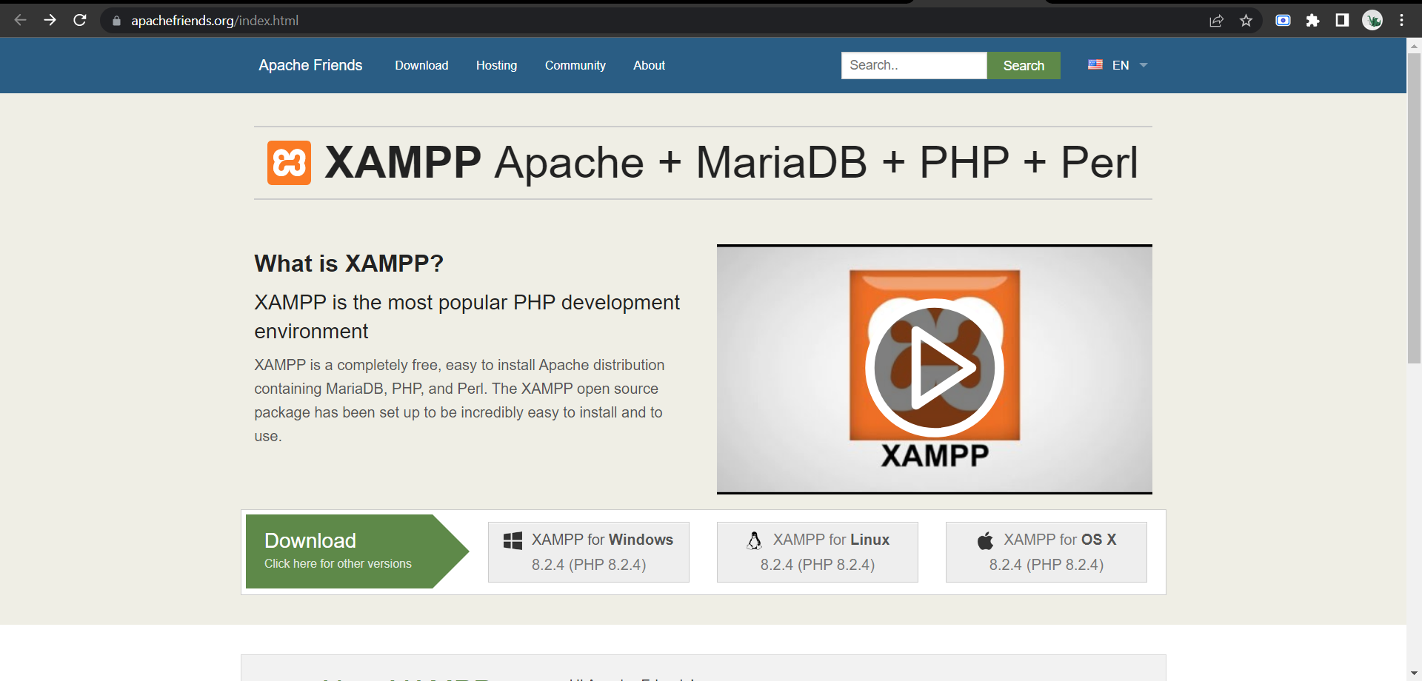

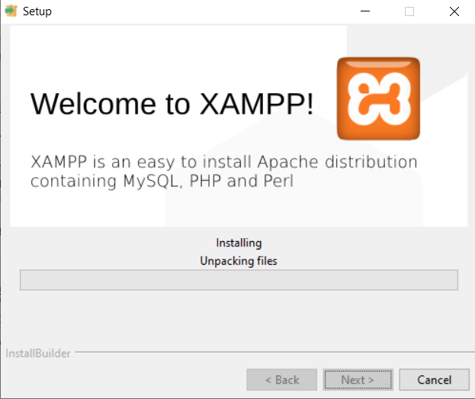

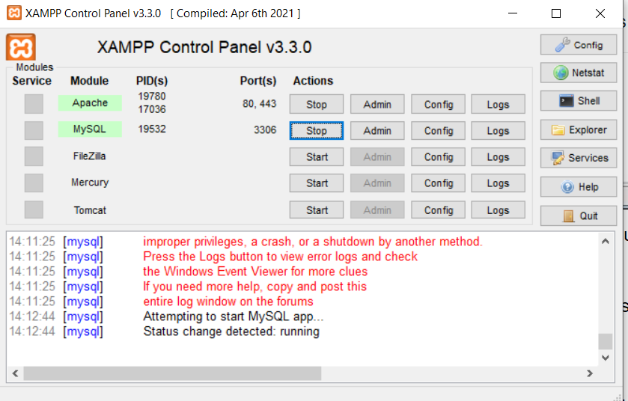

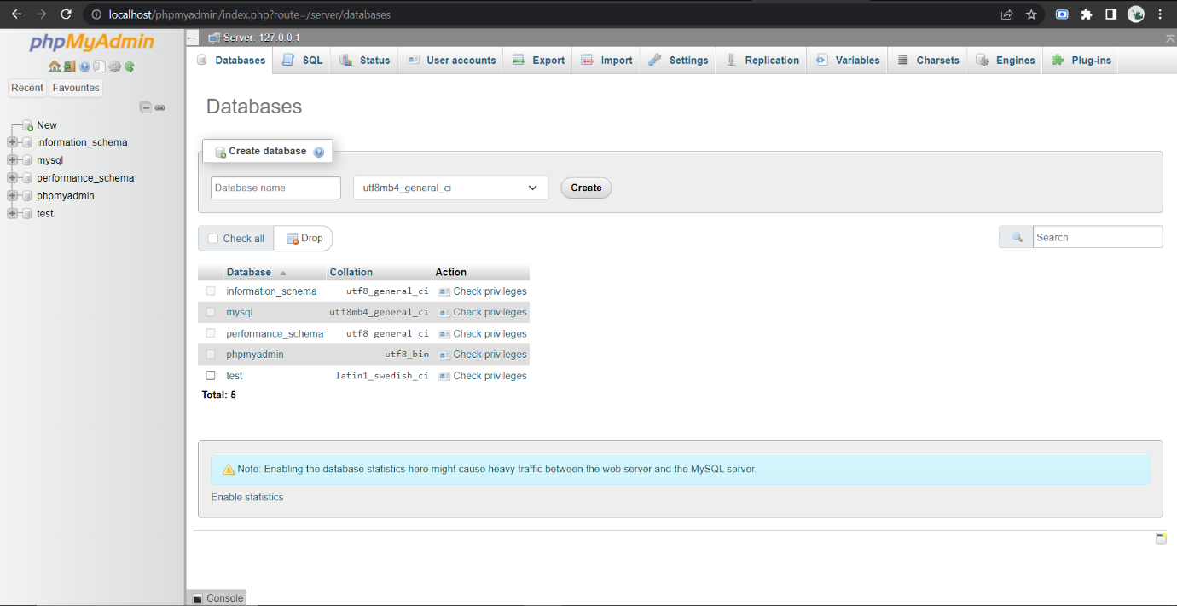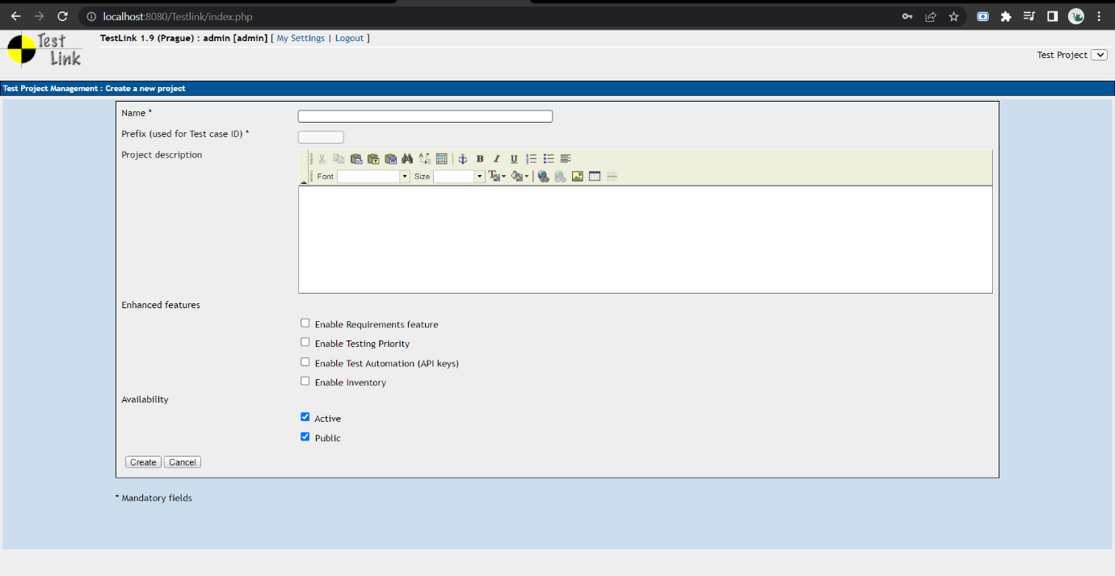

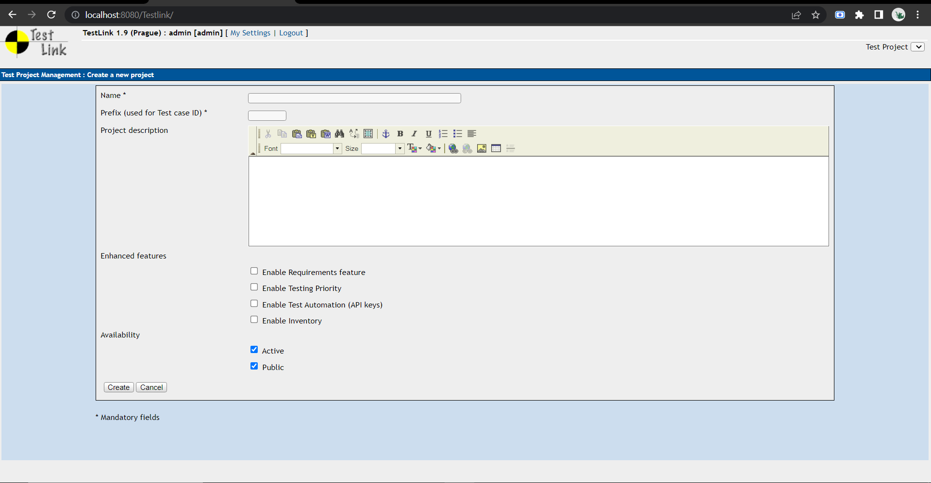

Q 3. Using TestLink tool create multiple test cases (at least 10) on any application/project that you have implemented.

Perform below tasks

1. **Create New test project as SETProject**

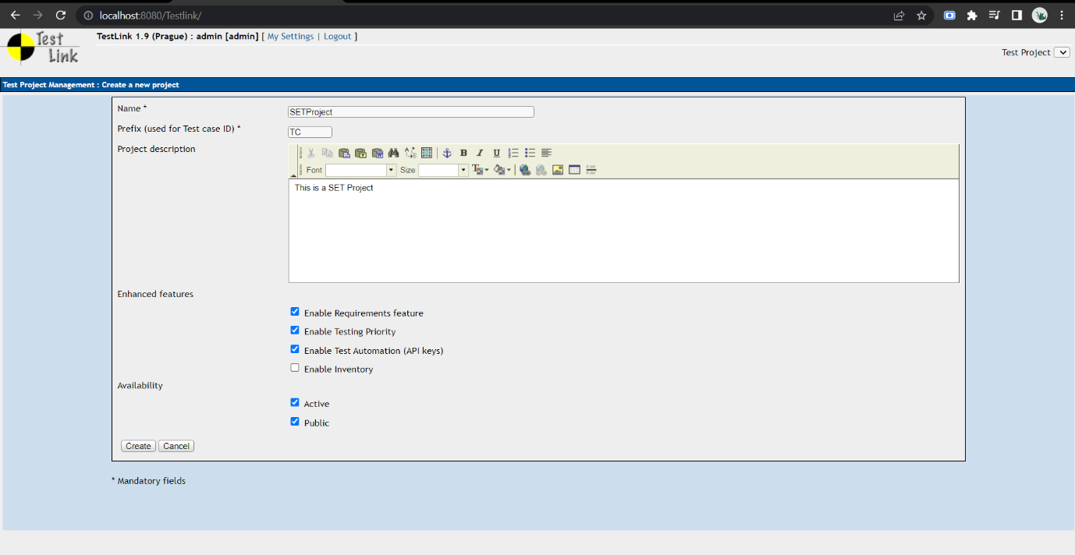

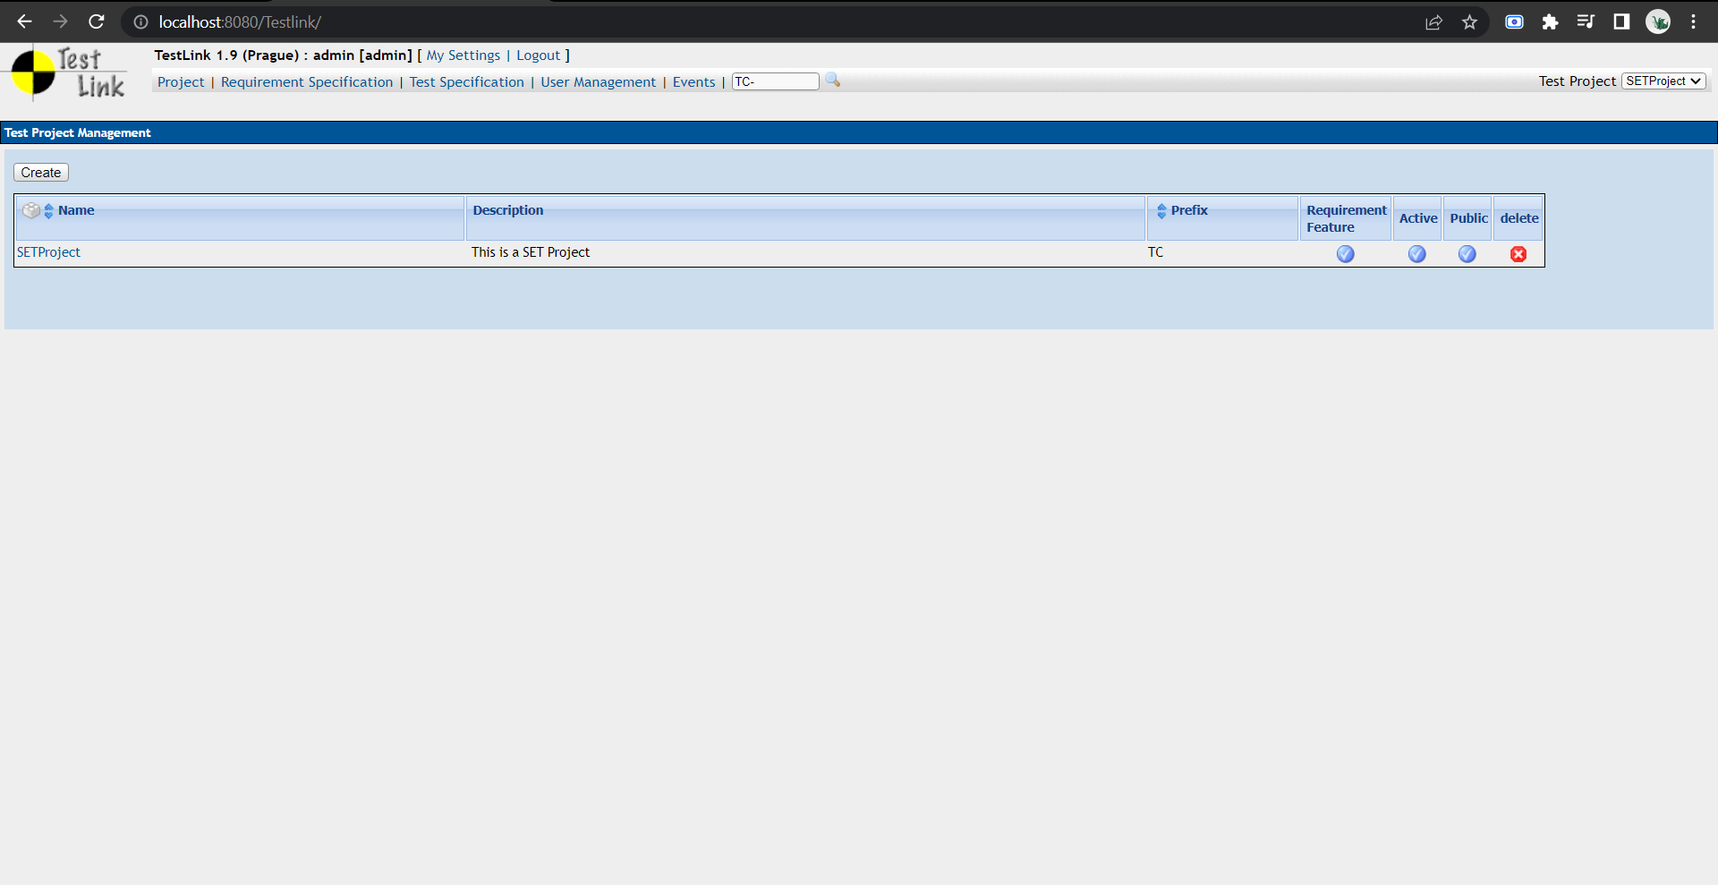

1. **Create a test plan as SETProjectTestPlan**

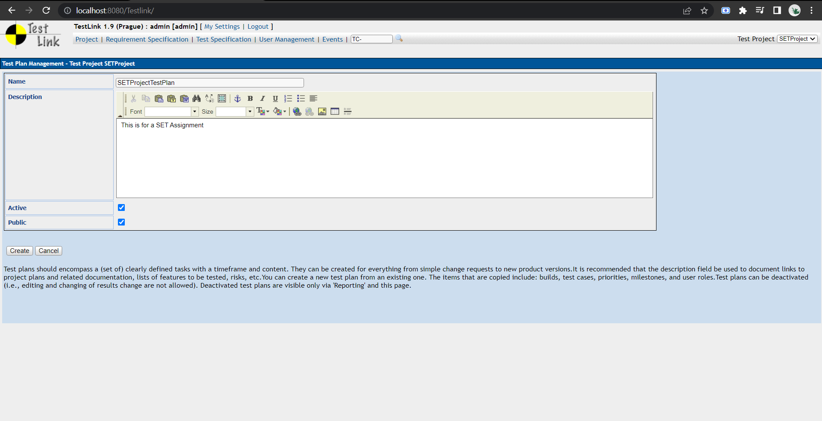

1. Create a build as SETProjectBuild

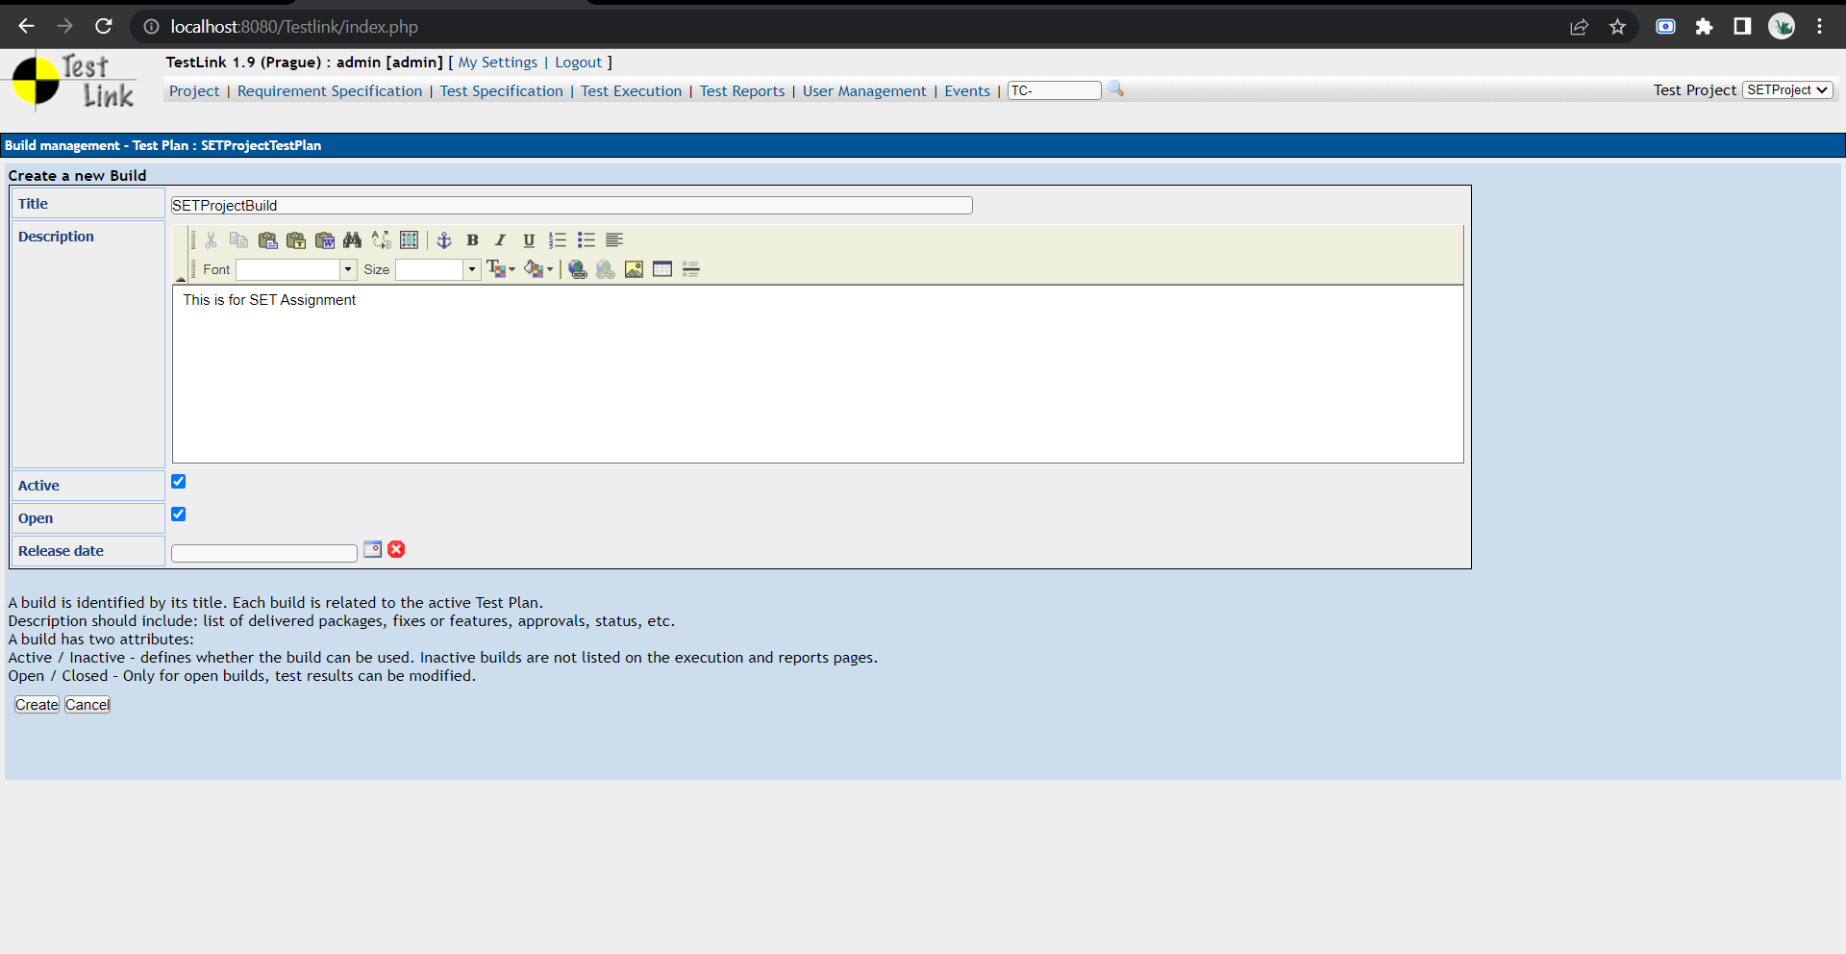

d. Create test suite as Test Suite 1 under SETProject

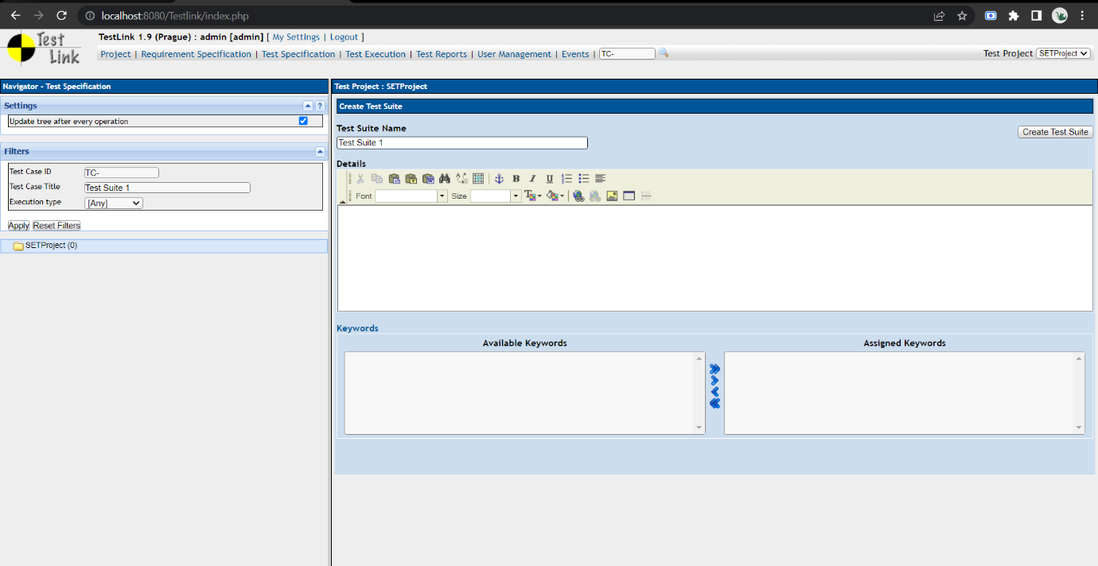

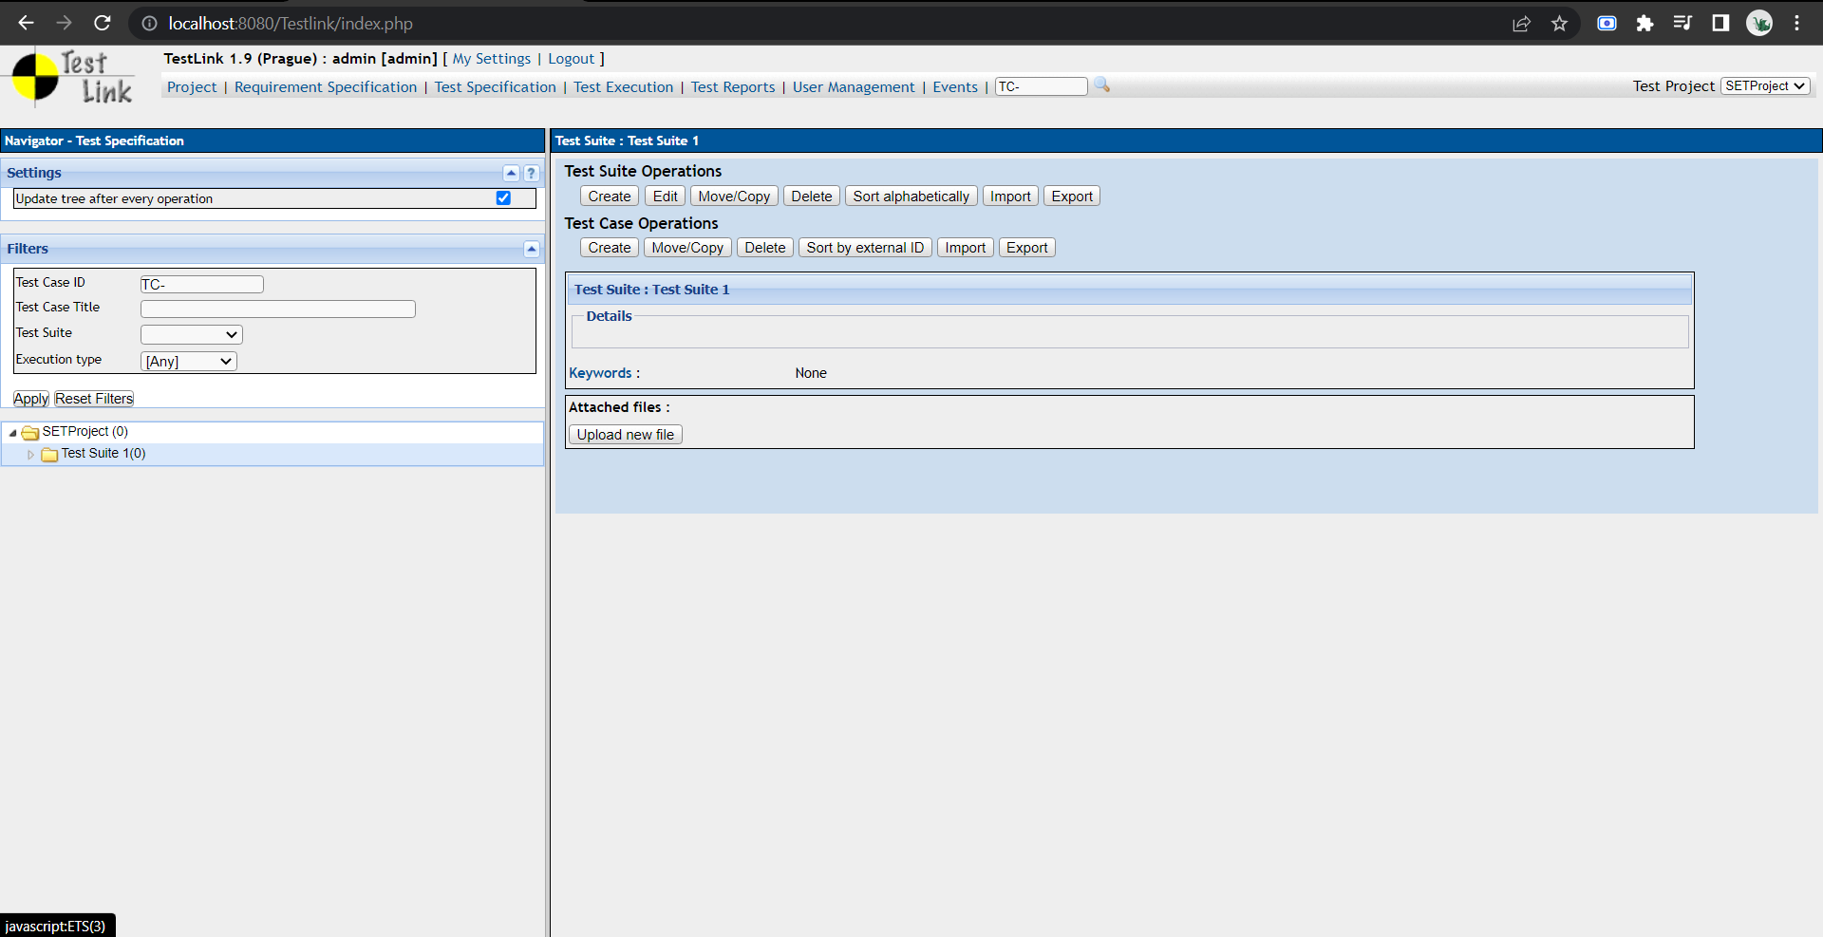

1. Create Test cases in TestLink Tool

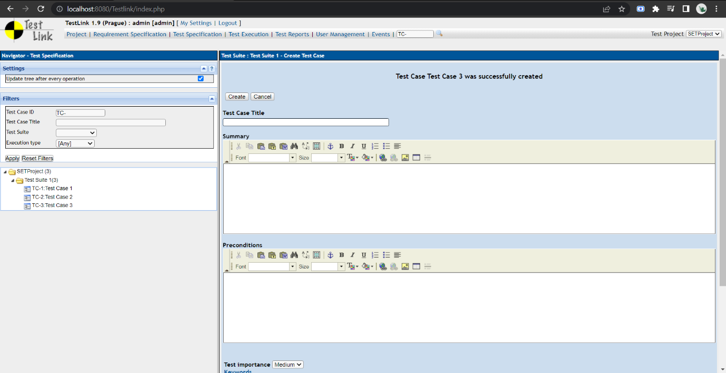

1. Assign created Test Cases to the test plan SETProjectTestPlan

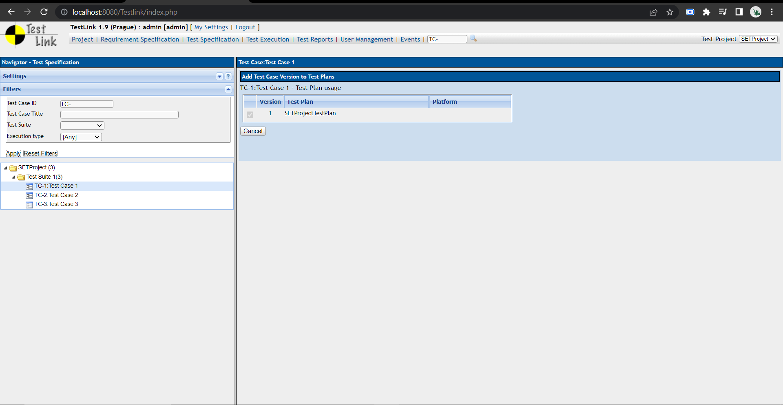

f. Create different roles as given below in the TestLink

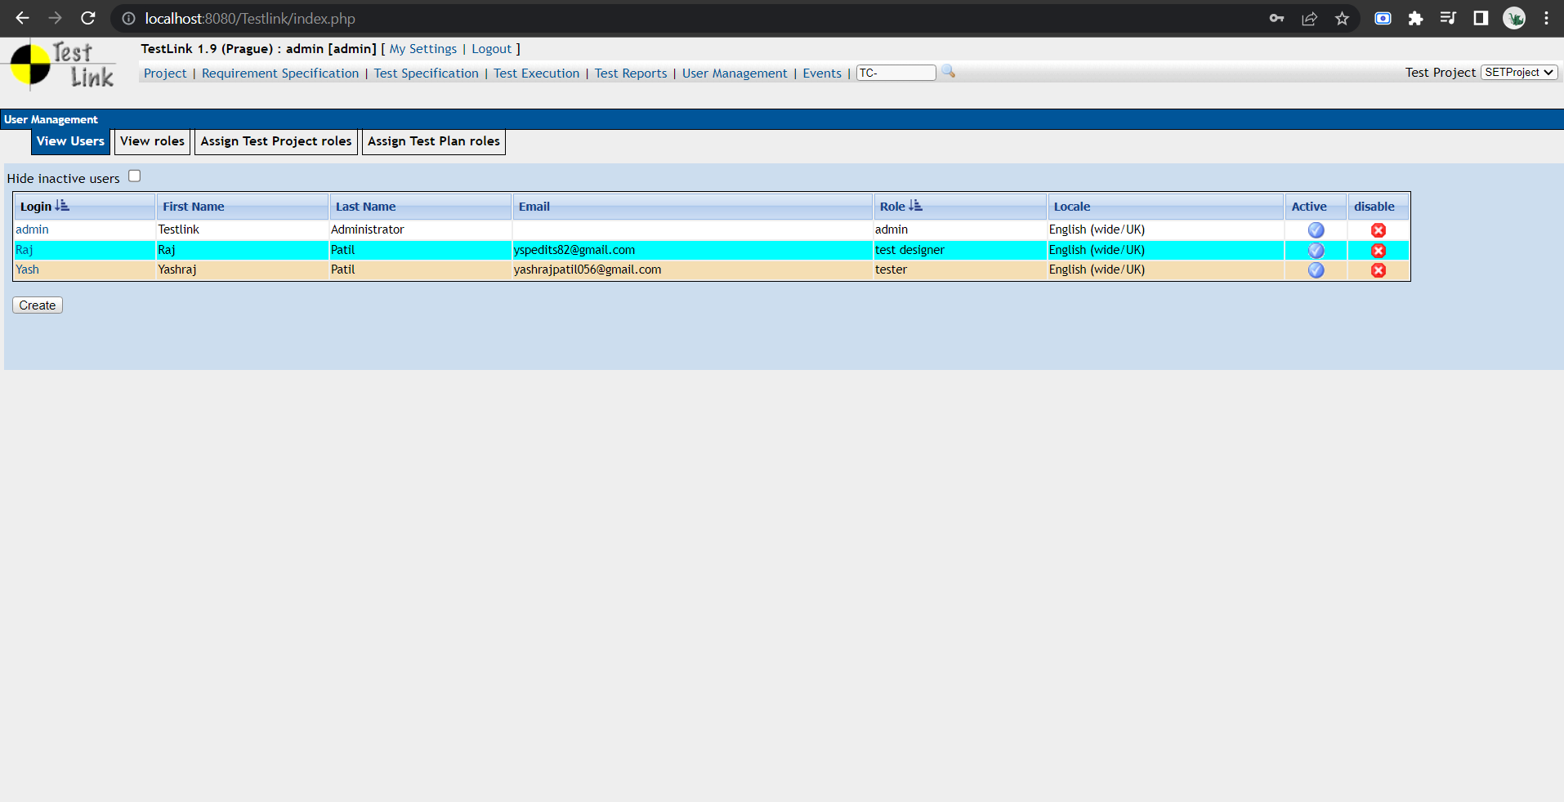

g. Write a requirements in TestLink

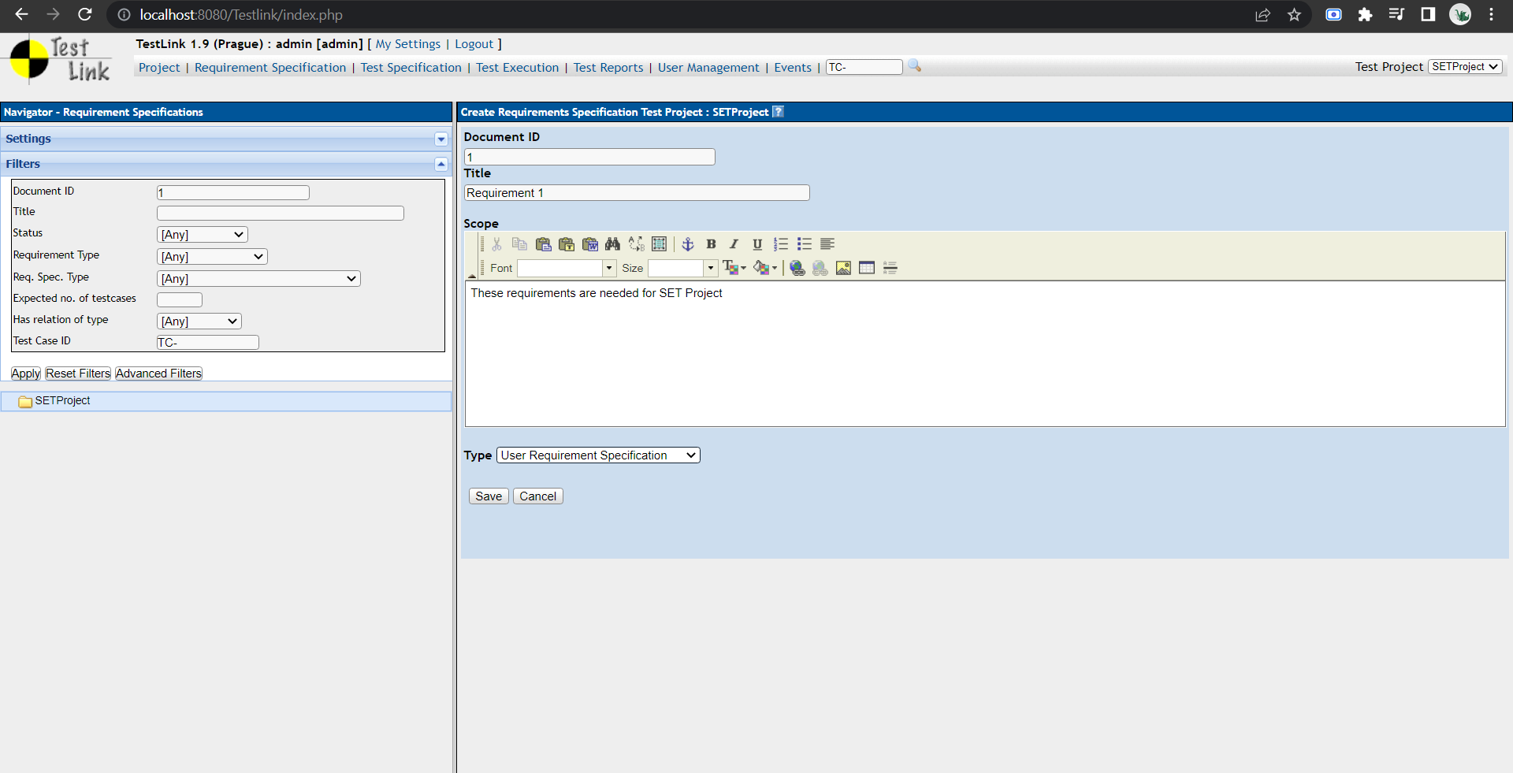

1. Execute test cases

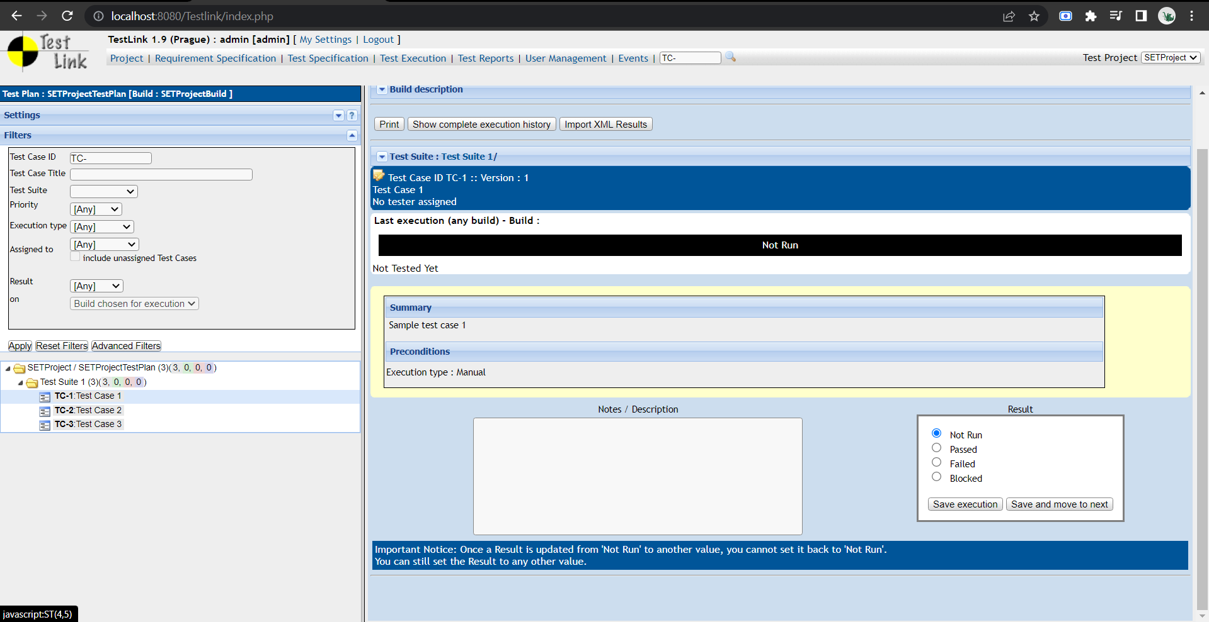

1. Generate a test report in excel format.

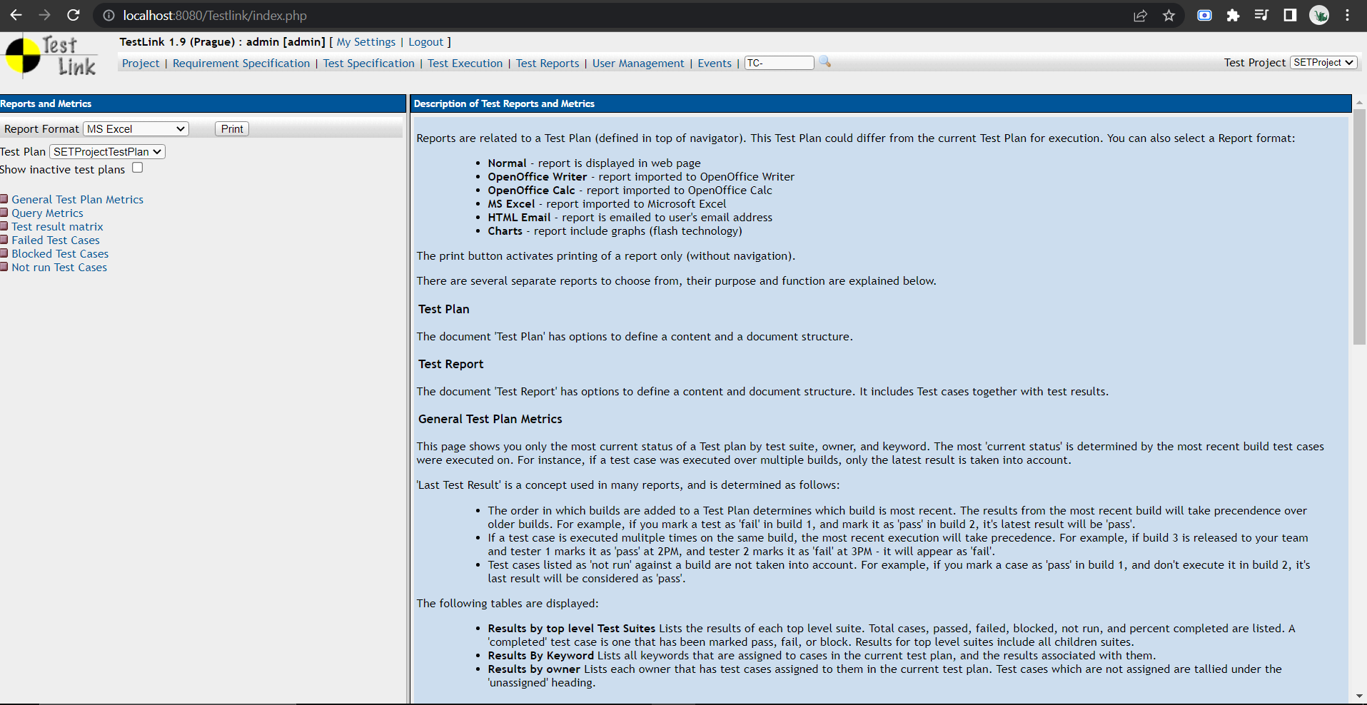

**Testlink Report:**

<https://drive.google.com/drive/folders/1Ge2o7Y0uKrupP954d5DneEYuvHdeWPNd?usp=sharing>